|  |  |
| --- | --- |
| Sony Alpha A6400  Máy ảnh Sony Alpha A6400 (Black) + Lens E 18-135mm F3.5-5.6 | Chính hãng  Sony Alpha a6400 + kit 18-135mm  Chính hãng.3 Sony Alpha a6400 + kit 18-135mm  Chính hãng.1 Sony Alpha a6400 + kit 18-135mm  Chính hãng.4 Sony Alpha A6400.5 | **Featured information:**  Sensor: APS-C  ISO range: 100 - 32000 (expandable 100 - 104200)  Resolution: 24.2MP  Wireless connection: WiFi, bluetooth  Price : $ 1250  Sensor Format  APS-C (1.5x Crop)  Resolution  25 Megapixels  Size photo  6000 x 4000  Image Proportions  3:2, 16:9  Sensor Type  CMOS  Image Format  JPEG, Raw  Anti-Vibration  Yes  Lens Mount  Sony E |

**Overview:**

The body of the Sony A6400 (ILCE-6400 / ILCE-6400L / ILCE-6400M) has almost no change in appearance compared to its A6000 mirrorless camera predecessors, the device still has a compact design, full of buttons. function to quickly control all parameters.

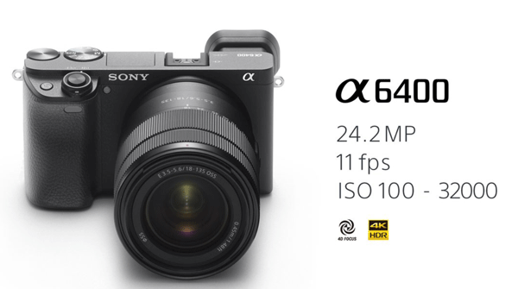

The Sony a6400 (body) is equipped with a 24.2MP APS-C image sensor combined with an upgraded BIONZ X processor to deliver improved image quality and color reproduction in all shooting conditions. Standard ISO goes up to ISO 32,000 for both stills and movies and is expandable up to ISO 102,400 for stills, with good noise reduction at medium and high sensitivities.



The Sony A6400 also inherits many image processing algorithms from Sony's full-frame camera lines, eliminating noise while retaining resolution and improving image sharpness.

Sony equips the Alpha A6400 with the ability to record 4K UHD/30p movies at 100 Mbps with full and zero pixel reading capabilities to collect about 2.4 times the amount of data needed for 4K movies, then Overwrite it to create high quality detail and depth.



Focusing during movie recording is fast and stable thanks to upgraded Fast Hybrid AF technology, keeping the subject in focus smoothly, even when a subject passes in front of the camera. This advanced touch AF functionality makes it a suitable camera choice for many vloggers and video creators who regularly create and upload online content.